William Watlington

August 14, 2022

WEB 335 – Introduction to NoSQL

Exercise 1.3 – UMLet Installation

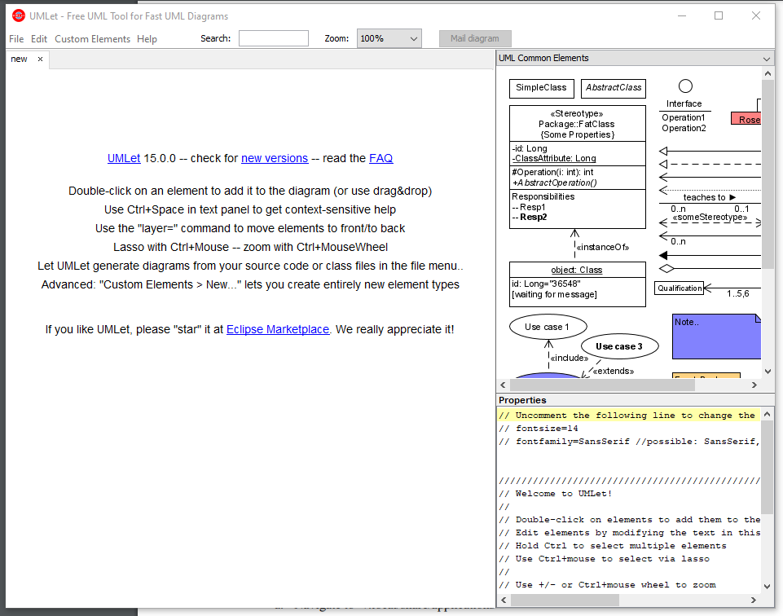Screenshot of UMLet running:

Screenshot of UMLet installation directory:

